German Electricity Demand Forecasting: From Benchmark Models to Deep Learning
Student Name and SRN:
LOKESWARI YARATAPALLI
24061216
Git-hub link:

1. Introduction
Accurate electricity demand forecasting is crucial for planning electricity generation, energy trading, and maintaining grid stability. Reliable forecasts enable electricity providers to optimize generation schedules, reduce operational costs, and enhance supply reliability.
Germany presents an interesting forecasting challenge due to its electricity demand being significantly influenced by seasonal weather patterns, industrial activity, and public holidays. This study aims to compare benchmark, statistical, machine learning, and deep learning approaches for forecasting German electricity demand, and to ascertain whether increasing model complexity leads to meaningful improvements in predictive performance.
2. Dataset and Data Preparation
Hourly German electricity demand data, spanning from January 2015 to September 2020, was sourced from the Open Power System Data repository. The dataset comprised 50,400 hourly observations, with no missing values or duplicate timestamps.
To investigate demand behaviour at different temporal resolutions and accommodate the needs of various forecasting models, the data was aggregated into daily and weekly averages.
Hourly Electricity Demand:
The hourly series exhibits notable short-term fluctuations, driven by daily consumption patterns and variations in residential and industrial electricity usage.
Daily Electricity Demand:
The daily aggregation smooths out hourly variations, more clearly revealing medium-term trends and seasonal behaviour.
Weekly Electricity Demand:
The weekly series highlights the underlying long-term trend and strong annual seasonality, making it well suited for forecasting and time-series modelling.
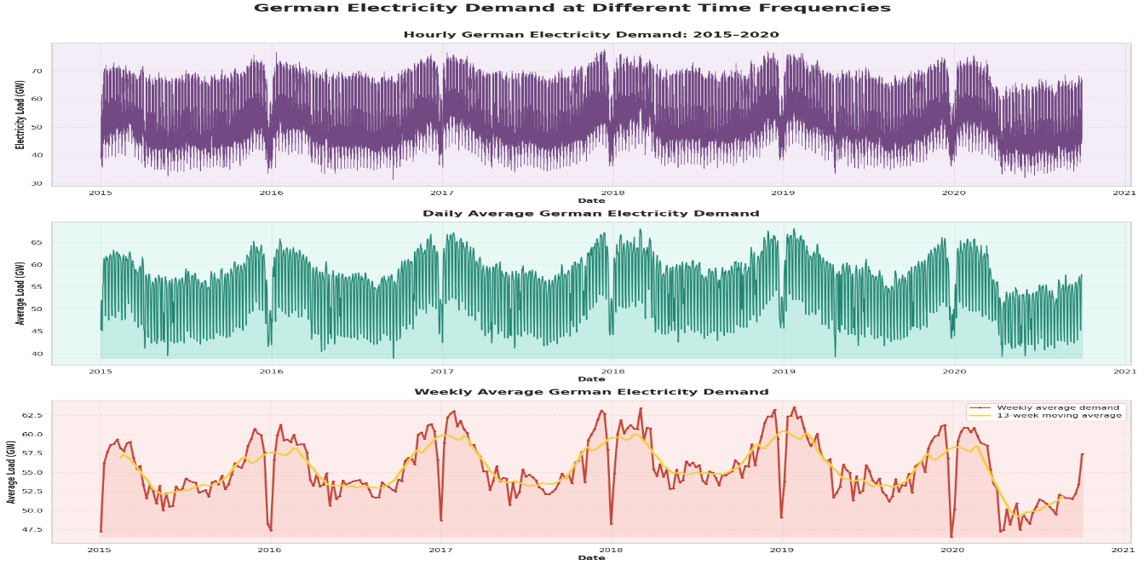
Figure 1: Hourly, Daily and Weekly German Electricity Demand (2015–2020)
Table 1: Dataset Summary
Dataset | Observations

Hourly | 50,400

Daily | 2,100

Weekly | 301
Visual inspection revealed a pronounced annual seasonality, with demand peaks occurring during winter months and lower demand during summer periods. Seasonal decomposition further confirmed the presence of trend, seasonal and residual components within the series.
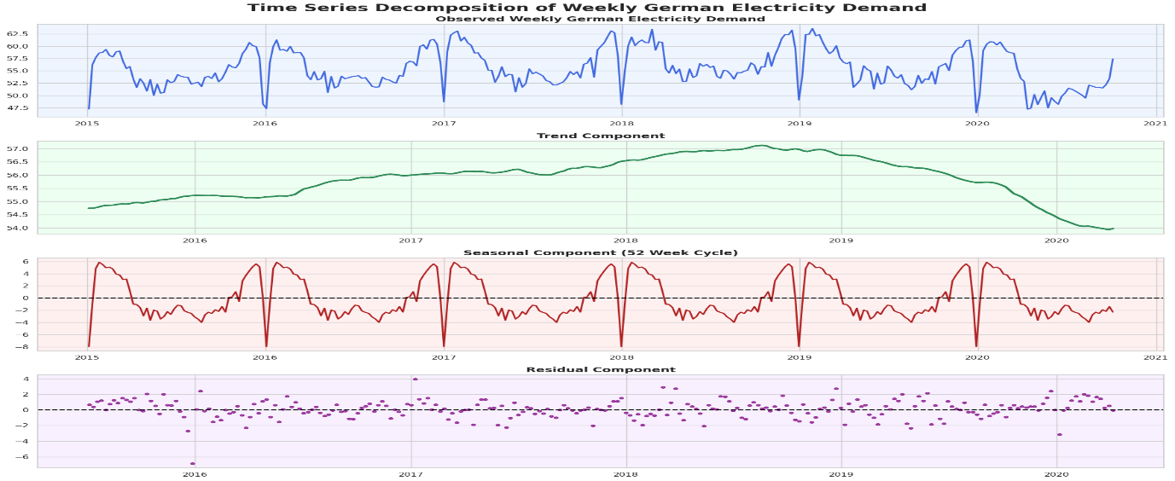
Figure 2: Seasonal Decomposition of Weekly Electricity Demand

Stationarity was assessed using the Augmented Dickey-Fuller (ADF) and KPSS tests.
Table 2: Stationarity Test Results
Test Statistic p-value
ADF -4.048 0.001
KPSS 0.160 0.100
The ADF test did not reject the presence of a unit root, while KPSS failed to reject stationarity. This indicates that the weekly demand series was sufficiently stationary for autoregressive modelling.
Autocorrelation analysis demonstrated strong seasonal behaviour around lag 52 weeks, supporting the use of seasonal forecasting models.
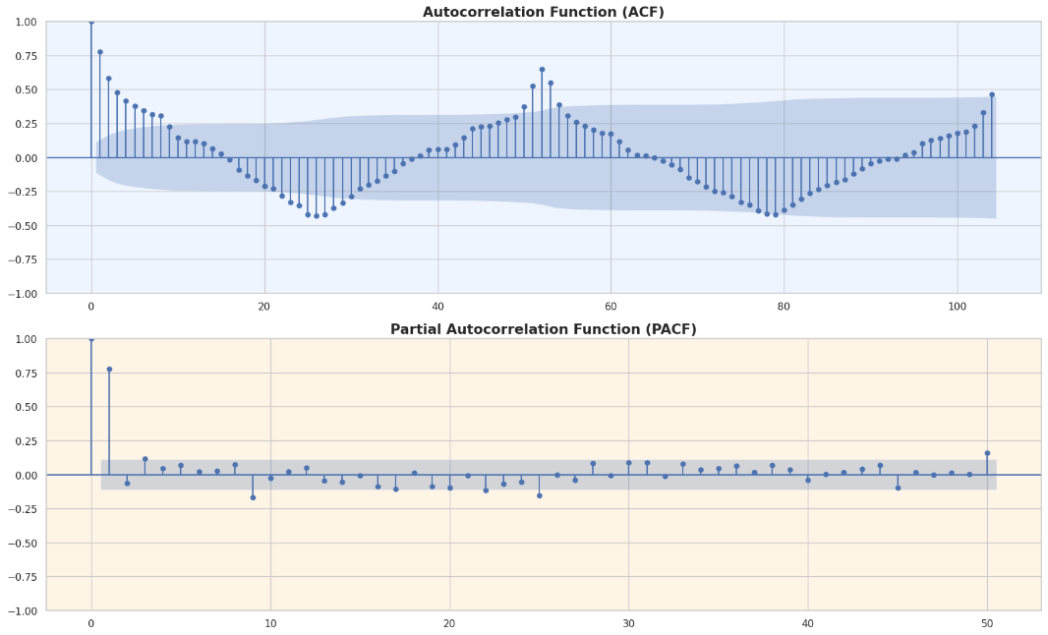
Figure 3: ACF and PACF of Weekly Electricity Demand
3 Methodology
3.1 Benchmark Models
Four benchmark models were implemented:
- Mean Forecast
- Naive Forecast
- Seasonal Naive Forecast
- Drift Forecast
These models serve to baseline performance and determine whether more sophisticated approaches offer meaningful improvements.
3.2 SARIMA
SARIMA was chosen because electricity demand displays strong seasonal autocorrelation. Model parameters were selected using AIC optimization with, the seasonal period was fixed at 52 weeks to capture annual seasonality.
3.3 SARIMAX
Electricity demand is heavily influenced by weather conditions. SARIMAX enhances SARIMA by incorporating exogenous variables, including:
Mean weekly temperature
Heating degree days
Cooling degree days
Holiday indicators
3.4 Feature-Based Regression
A Hist Gradient Boosting Regressor was selected because gradient boosting excels with structured tabular data and effectively captures nonlinear interactions.
The model incorporated:
Lag variables
Rolling averages
Fourier seasonal terms
Calendar variables
Temperature variables
3.5 LSTM
LSTM networks were chosen because they can learn long-term temporal dependencies directly from historical observations without requiring extensive manual feature engineering.
The model featured two LSTM layers with dropout regularization and a dense output layer. One week of historical observations (168 hours) was used as input.
4. Results and Discussion
4.1 Benchmark Models
The benchmark models established baseline forecasting performance for comparison against more sophisticated approaches.
The Seasonal Naïve model achieved the best benchmark performance, suggesting that German electricity demand follows highly repetitive annual cycles and contains significant seasonal information.
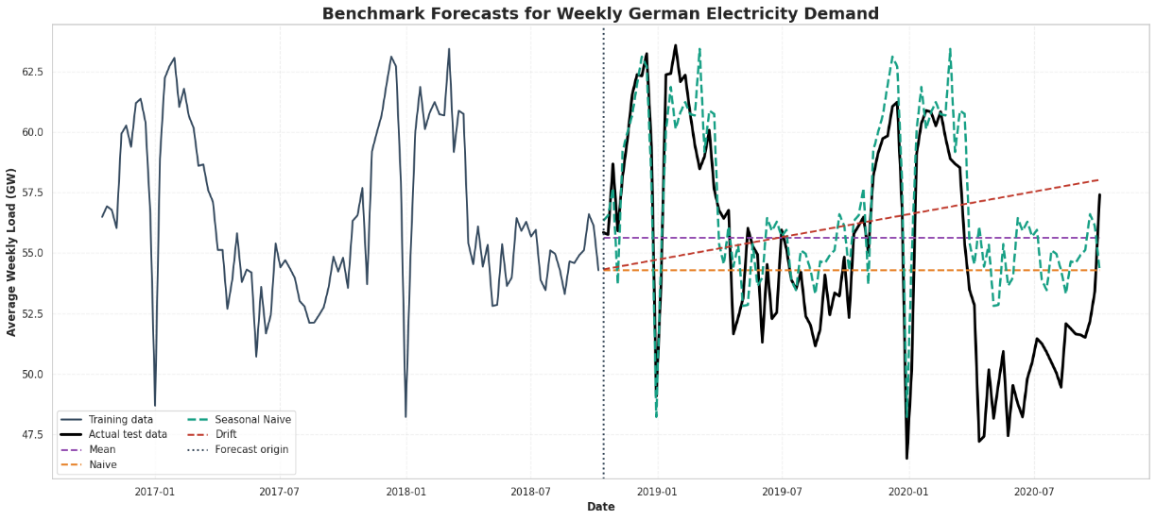

Figure 4: Benchmark Forecast Comparison
4.2 SARIMA Performance
SARIMA did a good job of capturing the annual seasonality, but it didn't perform better than the Seasonal Naive model. This suggests that past yearly patterns already explain a lot of the variation in demand
.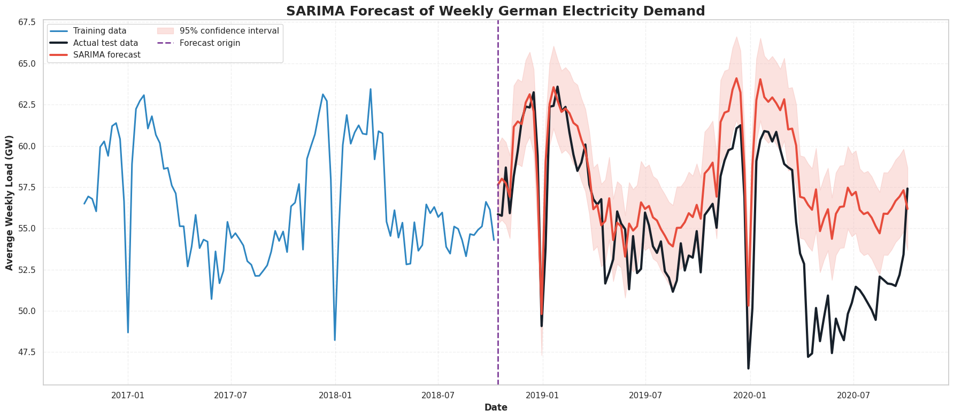
Figure 5: SARIMA Forecast with 95% Confidence Intervals
4.3 SARIMAX Performance
The figure below shows the temperature variables that were used as external factors in the SARIMAX models. Heating degree days go up during colder times, while cooling degree days stay quite low for most weeks.
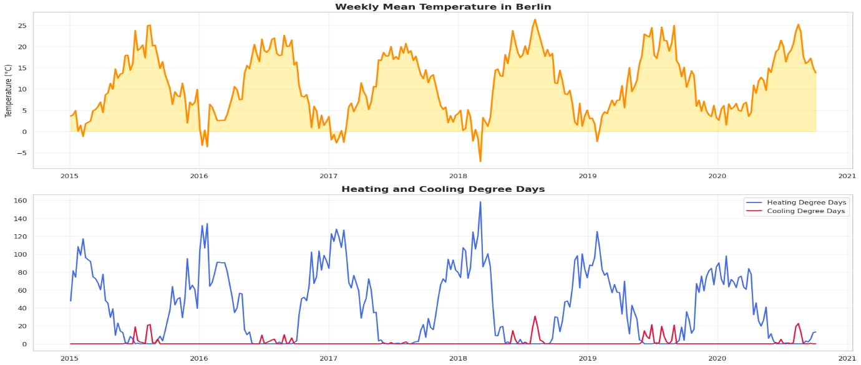
Figure 6: Weekly Berlin Temperature and Heating and Cooling Degree-Day Features
These temperature factors were included in the SARIMAX model to account for weather-related shifts in electricity demand.
4.4 Feature-Based Regression
The model that used features performed the best at forecasting weekly demand. By combining lag variables, rolling averages, and weather data, this model was better at capturing non-linear relationships than SARIMA.
4.5 LSTM Performance
The LSTM achieved an RMSE of 1.852, which was the lowest score among all the models tested. It was successful in capturing hourly demand patterns and short-term temporal dependencies.
However, the LSTM used a rolling one-step-ahead evaluation method, where past observed hours were used to predict the next hour. This is different from the fixed-origin, two-year forecasting approach used for the weekly models. Therefore, the LSTM's results should be considered separately and not directly compared to the long-horizon forecasts.
Additionally, the LSTM required more computing power, took longer to train, and was less interpretable than the statistical and feature-based models.
5. Critical Analysis and Discussion
The Seasonal Naive model was hard to beat because German electricity demand follows very predictable annual patterns.
Adding temperature variables improved the forecasting accuracy, showing how important weather information is for modelling electricity demand.
The feature-based model performed best by combining lag variables, rolling statistics, and weather features to capture both short-term and seasonal trends.

While the LSTM successfully captured hourly demand patterns, its higher computational cost and lower interpretability might make it less practical for real-world use.
Table 4: Final Model Comparison
Model | RMSE
LSTM | 1.852
Feature Model | 2.444
Seasonal Naive | 3.007
SARIMAX + Holidays | 3.510
SARIMAX Temperature | 3.580
SARIMA | 3.736
Mean | 4.397
Naive | 4.459
Drift | 5.118
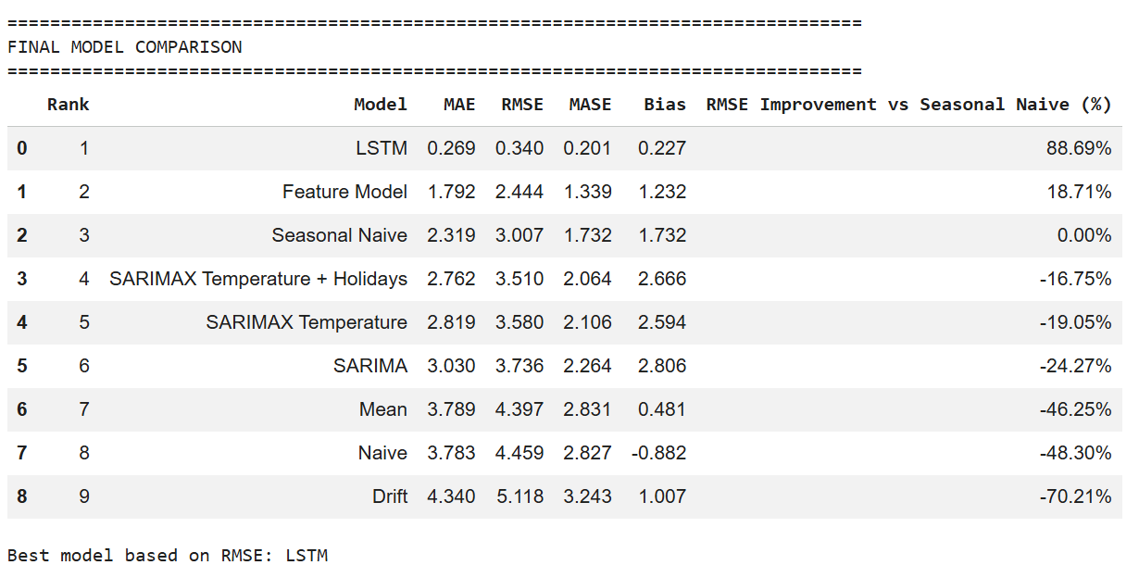
Figure 7: Final Model Comparison Using RMSE
The LSTM had the lowest numerical RMSE, but its rolling hourly evaluation couldn't be directly compared to the fixed-origin weekly forecasts. Among the weekly models, the feature-based model achieved the best accuracy with an RMSE of 2.444. It also offered a better balance of forecasting performance, interpretability, computational efficiency, and maintenance needs.
5.1 Comparing with the Seasonal Naive Benchmark
The Seasonal Naive model served as a robust benchmark, given the distinct yearly seasonality present in electricity demand. Among the weekly models, the feature-based model demonstrated the most significant improvement, whereas the LSTM model yielded the lowest overall RMSE.
5.2 Preventing Data Leakage
Data leakage was prevented by consistently applying chronological train-test splitting and by constructing lag and rolling features solely from historical data.
5.3 Selecting the SARIMAX Model
A seasonal period of 52 weeks was chosen due to the pronounced annual seasonality observed in the weekly data. The differencing orders were determined through AIC optimization during the model selection process.
5.4 Impact of Temperature and Holiday Covariates
Temperature had a minor positive effect on forecast accuracy, while holiday variables offered only a slight additional benefit. Holiday dates are known in advance, unlike future temperatures, which necessitate weather forecasts.
5.5 Model Interpretability and Complexity
The SARIMAX model was the most interpretable. The feature-based model struck a good balance between accuracy and complexity, while the LSTM was the most computationally intensive and least interpretable.
5.6 Recommended Model
The feature-based model is recommended for operational weekly forecasting as it offers the optimal balance of accuracy, interpretability, and maintenance requirements.
6. Conclusion
German electricity demand shows strong annual seasonality and is significantly influenced by weather conditions.
The Seasonal Naive model served as a strong baseline, and adding temperature and holiday variables improved the SARIMAX model's performance. The LSTM achieved the lowest numerical RMSE of 1.852 in its rolling hourly evaluation. However, because this evaluation used previously observed test hours, it wasn't directly equivalent to the fixed-origin weekly forecasts.
Among the weekly models that could be directly compared, the feature-based model achieved the best RMSE of 2.444. It is recommended for operational weekly forecasting due to its excellent balance of accuracy, interpretability, computational efficiency, and maintenance requirements.
Future research should involve comparing all models using the same evaluation method, whether rolling-origin or fixed-origin.
References
Hochreiter, S. and Schmidhuber, J. (1997) Long Short-Term Memory. Neural Computation, 9(8), pp.1735-1780.
Hyndman, R.J. and Athanasopoulos, G. (2021) Forecasting: Principles and Practice. 3rd Edition. Melbourne: OTexts.
James, G., Witten, D., Hastie, T. and Tibshirani, R. (2021) An Introduction to Statistical Learning. 2nd Edition. New York: Springer.
Géron, A. (2022) Hands-On Machine Learning with Scikit-Learn, Kera’s and TensorFlow. 3rd Edition. Sebastopol: O'Reilly Media.
Open Power System Data (2020) Time Series Data Package. Available at: https://data.open-power-system-data.org/time_series/

